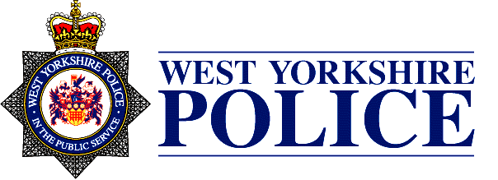

**The Police and Crime Commissioner for West Yorkshire and the Chief Constable of West Yorkshire Police**

**Closure of Audit 2019/20**

NOTICE is given that the Audit of Accounts for the year ended 31 March 2020 has been concluded.

NOTICE is also given that the Statement of Accounts for the Police and Crime Commissioner Group for West Yorkshire and the Chief Constable of West Yorkshire Police are available for inspection by any local government elector within the County of West Yorkshire.

The inspection would usually be undertaken between the hours of 9.00am and 4.00pm Monday to Friday at Wakefield One, Burton Street, Wakefield, WF1 2DD. However, due to the recent pandemic, alternative arrangements have been made. Therefore, If you wish to inspect the accounts applications should be made initially to the Treasurer, Office of the Police and Crime Commissioner for West Yorkshire via email - [contact@westyorkshire.pcc.pnn.gov.uk](mailto:contact@westyorkshire.pcc.pnn.gov.uk) from the date hereof.

Copies of the statement of the accounts will be available on the Police and Crime Commissioner’s website: www.westyorkshire-pcc.gov.uk and the Force’s website: www.westyorkshire.police.uk

Any elector as aforesaid may make a copy of the Statements and may on application to the Chief Finance Officer have copies of the Statements delivered to him/her.

This is a statutory notice as required by Regulation 16(1) of the Accounts and Audit Regulations 2015.

Ms Katherine Johnson

Treasurer

Office of the Police and Crime Commissioner for West Yorkshire

Ms Katherine Johnson

Assistant Chief Officer, Business Operations

West Yorkshire Police